ABSTRACT
It is always a complex procedure to diagnose autism spectrum disorder (ASD) because there is no particular medical test for autism, like a blood test, to make a diagnosis for the disorder. Autism spectrum disorder is defined by the disability and impairments of participating in social communication or the presence of restricted or repetitive behaviors, or both. It is a behaviorally diagnosed condition. To make a diagnosis, doctors look at the child's developmental history and behavior. Apparently, most children do not attain a proper diagnosis for autism until it is too late. In some cases, parents are reluctant to accept that their child's mental growth is not developing along with the child's physical growth. This lateness in diagnosis hinders a child's ability to get the help they need to keep developing. It is important to diagnose ASD as early as possible through monitoring, screening, and evaluating a child's development so that we can ensure proper care and support for an autistic child to help them reach their full potential. So, we are developing a system that will have the ability to diagnose Autism and come up with a reliable and effective conclusion even without the help of a professional. We hope this system will be very helpful for those concerned parents who are worried about their child's growth and activities, at the same time it will be very useful for the professionals.

CHAPTER 1
INTRODUCTION
1.1 Project Overview
Autism, formally known as Autism Spectrum Disorder (ASD), is a complex neurodevelopmental condition that affects individuals in various ways. It is characterized by a wide range of symptoms and challenges that primarily impact social interaction, communication, and behavior. Autism is often described as a "spectrum" disorder because it manifests differently in each person, with varying degrees of severity and a diverse array of strengths and difficulties.
Autism typically becomes apparent in early childhood, often before the age of three. However, it can continue to influence an individual's life throughout their lifespan. While the exact cause of autism remains the subject of ongoing research, it is believed to result from a combination of genetic and environmental factors.
    - Some common features of autism include:
Social Challenges: Individuals with autism may have difficulty with social interactions, including understanding social cues, maintaining eye contact, and forming relationships.
Communication Difficulties: Many people with autism experience challenges in verbal and nonverbal communication. Some may have delayed speech development, while others may struggle with expressive and receptive language skills.
Repetitive Behaviors: Individuals with autism often engage in repetitive behaviors or routines. These behaviors can include hand-flapping, rocking, or an intense focus on specific interests or topics.
Sensory Sensitivities: Sensory sensitivities are common in autism. Individuals may be hypersensitive (overreacting to sensory stimuli like lights, sounds, or textures) or hyposensitive (underreacting to sensory stimuli).
Strong Interests: Many individuals with autism have intense and focused interests in specific subjects or activities, often referred to as "special interests." These interests can be a source of passion and expertise.

1.4 Motivation of the Project:
The motivation behind an Autism Spectrum Disorder (ASD) detection project is rooted in the desire to improve early diagnosis, intervention, and support for individuals with autism.
Early Intervention: Early detection of autism can lead to early intervention, which is crucial for improving outcomes in individuals with ASD. Research suggests that early behavioral and educational interventions can significantly enhance cognitive and social development in children with autism.
Improved Quality of Life: Timely diagnosis and intervention can enhance the overall quality of life for individuals with autism and their families. It allows for tailored support and strategies to address specific challenges associated with ASD.
Reducing Stigma: Early detection can help reduce the stigma associated with autism by promoting a better understanding of the condition. This understanding can lead to increased acceptance and support within communities.
Research Advancements: ASD detection projects contribute to a better understanding of the condition. By collecting and analyzing data related to early signs and symptoms, researchers can identify patterns and risk factors, potentially leading to advancements in the field.

1.5 Dataset:
One well-known dataset for autism spectrum disorder (ASD) detection is the Autism Diagnostic Interview-Revised (ADI-R) dataset. It includes structured interviews conducted with individuals to assess autism symptoms. Another widely used dataset is the Autism Brain Imaging Data Exchange (ABIDE), which provides neuroimaging data for ASD research.

CHAPTER 2
LITERATURE SURVEY
Title: Analysis and Detection of Autism Spectrum Disorder Using Machine Learning Techniques
Authors: Suman Raj, Sararaz Masood
Year: 2020
Description: in this paper there is an attempt to explore the possibility to use Naïve Bayes, Support Vector Machine, Logistic Regression, KNN, Neural Network and Convolutional Neural Network for predicting and analysis of ASD problems in a child, adolescents, and adults. The proposed techniques are evaluated on publicly available three different non-clinically ASD datasets. First dataset related to ASD screening in children has 292 instances and 21 attributes. Second dataset related to ASD screening Adult subjects contains a total of 704 instances and 21 attributes. Third dataset related to ASD screening in Adolescent subjects comprises of 104 instances and 21 attributes. After applying various machine learning techniques and handling missing values, results strongly suggest that CNN based prediction models work better on all these datasets with higher accuracy of 99.53%, 98.30%, 96.88% for Autistic Spectrum Disorder Screening in Data for Adult, Children, and Adolescents respectively.

Title: A new computational intelligence approach to detect autistic features for autism screening
Auhtors: Fadi Thabtah, Firuz kamalov, Khairan Rajab
Year: 2018
Description: This study aims at identifying fewer, albeit influential, features in common ASD screening methods in order to achieve efficient screening as demands on evaluating the items' influences on ASD within existing tools is urgent. To achieve this aim, a computational intelligence method called Variable Analysis (Va) is proposed that considers feature-to-class correlations and reduces feature-to-feature correlations. The results of the Va have been verified using two machine learning algorithms by deriving automated classification systems with respect to specificity, sensitivity, positive predictive values (PPVs), negative predictive values (NPVs), and predictive accuracy. Experimental results using cases and controls related to items in three common screening methods, along with features related to individuals, have been analysed and compared with results obtained from other common filtering methods. The results exhibited that Va was able to derive fewer numbers of features from adult, adolescent, and child screening methods yet maintained competitive predictive accuracy, sensitivity, and specificity rates.

Title: Early Diagnosis of Autism Spectrum Disorder: A Review and Analysis of the Risks and Benefits
Authors: Chiugo Okoye, Chidi M Obialo-Ibeawuchi, Omobolanle A Obajeun
Year: 2023
Description: This project aims to explore some of its signs and symptoms, look into some diagnostic tools, and analyze the benefits and risks associated with an early diagnosis of autism.
The symptoms of ASD vary from child to child, some of which are: avoidance of eye contact, lack of response to names, excessive fear, and lack of interactive and pretend play. Early identification of these symptoms by caregivers and healthcare providers facilitates the need for diagnosis and appropriate interventions. Some screening and diagnostic tools that have been found to help make the diagnosis are the Modified Checklist for Autism in Toddlers, Revised with Follow-Up (M-CHAT-R/F), the Social Communication Questionnaire (SCQ), the Parents' Evaluation of Developmental Status (PEDS), and the Childhood Autism Rating Scale (CARS), amongst others.The benefits of early diagnosis include the opportunity for early intervention, which has been shown to enhance developmental outcomes and improve adaptive skills.

Title: Applying machine learning to identify autistic adults using imitation: An exploratory study
Authors: Baihua Li, Arjun Sharma, James Meng, Emma Gowen
Year: 2017
Description: The aim of this study was to investigate whether data-driven machine learning based methods could be used to address some fundamental problems with regard to identifying discriminative test conditions and kinematic parameters to classify between ASC and neurotypical controls. Data was based on a previous task where 16 ASC participants and 14 age, IQ matched controls observed then imitated a series of hand movements. 40 kinematic parameters extracted from eight imitation conditions were analysed using machine learning based methods. Two optimal imitation conditions and nine most significant kinematic parameters were identified and compared with some standard attribute evaluators. To our knowledge, this is the first attempt to apply machine learning to kinematic movement parameters measured during imitation of hand movements to investigate the identification of ASC. Although based on a small sample, the work demonstrates the feasibility of applying machine learning methods to analyse high-dimensional data and suggest the potential of machine learning for identifying kinematic biomarkers that could contribute to the diagnostic classification of autism.

CHAPTER 3
SYSTEM ANLYSIS
Machine learning models were prepared by executing multiple algorithms like Linear Regression, KNN, Random Forest and Decision Trees. A class diagram was initially created to understand the dataflow of the modules integrating both the frontend and backend.
The training datasets are fetched from an existing dataset provided. The training of the model was performed in jupyter notebook as well as google-collab platforms. Python language using pandas to implement the data sets into records and tables and implementing algorithms onto this training dataset to create models. Once these models were created the algorithm which gave the best efficiency during the validation process was recorded.
Using a streamlit platform the form was created for the user to fill as an input, which will be converted into an array for the machine learning model to compare the input with the dataset and give out the output whether the person has chances of having ASD or not. For frontend, a website with Homepage, Login and Registering page, Booking appointment, a userprofile page with dashboard, a gallery page is implemented using HTML, CSS and JavaScript languages.
The database is set in Firebase platform. A realtime database which updates and stores a new register of the patient as well as the patient's book appointment details. The cloud database is scalable and handles large amounts of data. The whole project is built on Visual Studio code and runs on a local server/host which acts as both client and a server.
3.1 Problem Statement
To be able to detect Autism and be able to inform the user at an early stage of suspicion rather than wait for a longer period of time of detection process. Our aim is to be able to build a user friendly system that can be utilized to effectively detect the presence of Autism in the individual by collecting their responses to some questions. As we have seen in the previous sections, detection at an early stage plays a vital role for any individual, so that an apt solution can be recommended by the doctor at the earliest to make the quality of life better.
The main objective is to develop an application which can allow the user to be able to find out whether he/she may have chances of being Autistic. Other objectives of this application is to be able to satisfy the need for early detection of Autism and provide necessary details about such a medical condition. The application also consists of available doctors who specialize in certain fields, this can be vital and informative to the user. Our aim is to make this web application user friendly and accessible.
3.2 EXISTING SYSTEM
- The major part of the existing literature on autism spectrum disorder is covered by a prediction system based on traditional machine learning algorithms such as Linear Regression, Logistic Regression, multiple layer perceptron and deep neural network.
- It's important to note that the effectiveness of these algorithms depends on the quality and diversity of the data used for training. Additionally, ethical considerations, interpretability of results, and the need for validation in diverse populations are crucial aspects of developing reliable ASD detection models.
- Using these machine learning model achieving very less accuracy such 67 to 72% with less precision, recall and F1 Square.
3.3 Proposed System
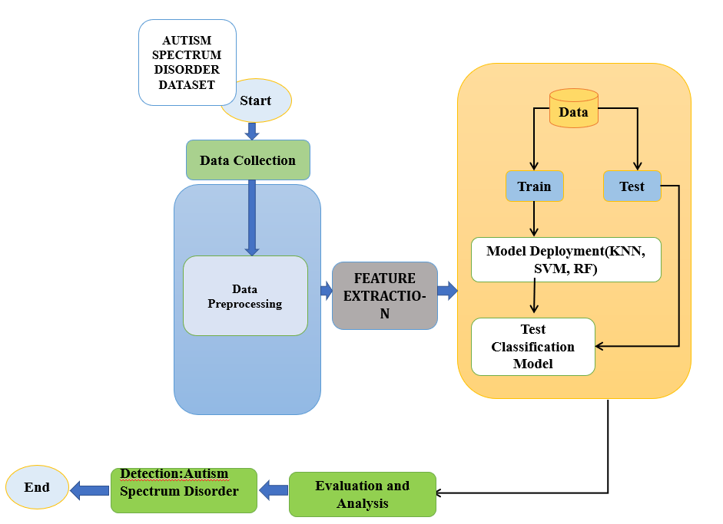
Figure 3.1: Proposed Diagram

Data Collection:
Gather diverse and representative datasets containing information relevant to ASD. This may include behavioral observations, speech patterns, eye-tracking data, neuroimaging scans, and genetic information.
Data Preprocessing:
Clean and preprocess the data to handle missing values, outliers, and noise. Normalize or standardize features to ensure consistent scales across different variables. This step is crucial for improving the performance of machine learning algorithms.
Feature Extraction:
Extract relevant features from the data that are likely to be informative for ASD detection. Feature selection methods, such as correlation analysis or feature importance from tree-based models, can help identify the most relevant features.
Training and Testing Data:
Split the dataset into training and testing sets. The model is trained on the training set and evaluated on the testing set, which simulates its performance on new, unseen data.
Algorithm Selection:
Choose appropriate machine learning algorithms based on the nature of the data and the problem at hand. Consider using a variety of algorithms such as Random Forests, Support Vector Machines, or KNN depending on the type of features and data available.
Deployment: Once satisfied with the performance, deploy the model in a user-friendly interface or integrate it into existing healthcare systems. Ensure proper security measures are in place to protect sensitive data.
Evaluation: Evaluate the model's performance on the testing set using appropriate evaluation metrics. For ASD detection, metrics such as accuracy, precision, recall, and F1-score can be used.
Detection: It would involve using a trained machine learning model to predict whether an individual may have ASD based on certain input features.

CHAPTER 4
SYSTEM DESIGN
System Design is the process of designing the architecture and components of a machine learning system to accomplish specific objectives efficiently and effectively. It encompasses decisions about data flow, model architecture, deployment strategies, and the overall structure of the system. critical phase that requires collaboration between data scientists, machine learning engineers, and domain experts.
4.1 DATA FLOW DIAGRAM –L0
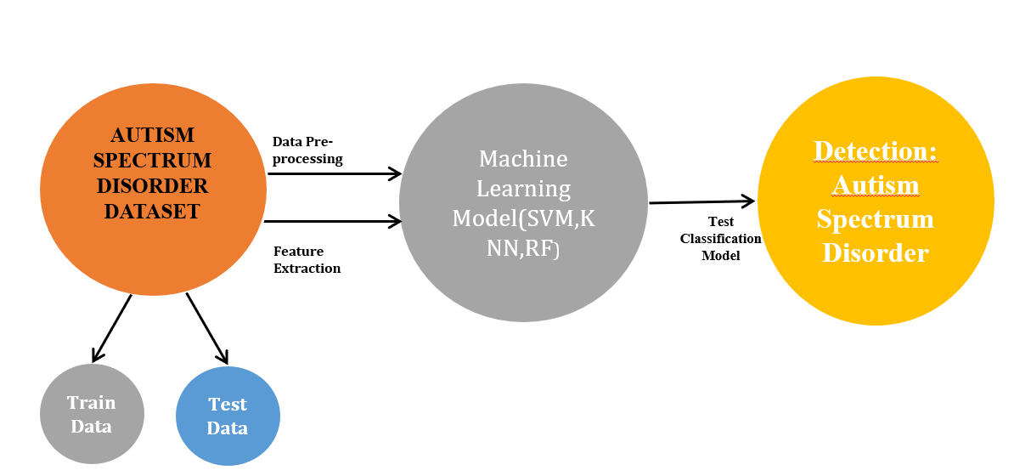
Figure 4.1: Data Flow Diagram –L0
A Level 0 Data Flow Diagram (DFD) provides a high-level overview of the entire system, depicting the major processes or functions and their interactions. In the context of Autism Spectrum Disorder (ASD) detection using machine learning, This Level 0 DFD provides a holistic view of the ASD detection system, from data collection to continuous improvement, emphasizing the major processes and their interactions.

4.2 DATA FLOW DIAGRAM –L1
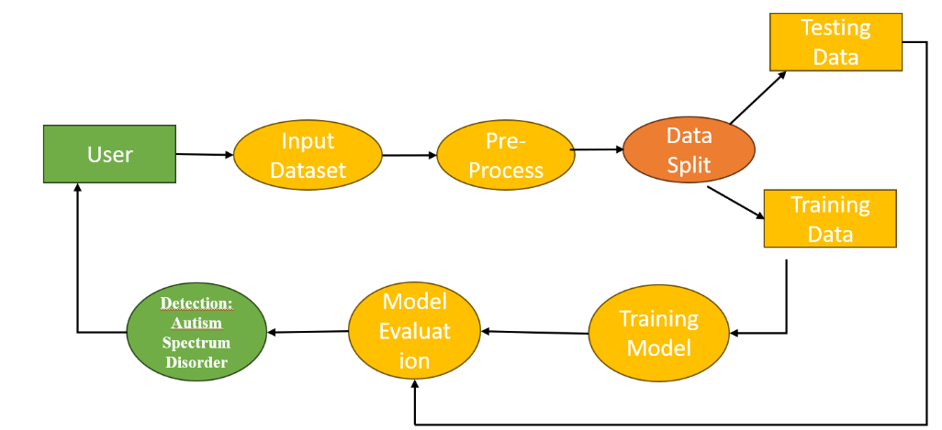
Figure 4.2: Data Flow Diagram –L0
A Level 1 Data Flow Diagram (DFD) provides a more detailed breakdown of the processes identified in the Level 0 DFD. In this case, I'll expand on the processes related to Autism Spectrum Disorder (ASD) detection, adding more detail to each subprocess. This Level 1 DFD provides a more detailed breakdown of the processes involved in ASD detection, extending the subprocesses introduced in the Level 0 DFD.
4.3 Use-Case Diagram:
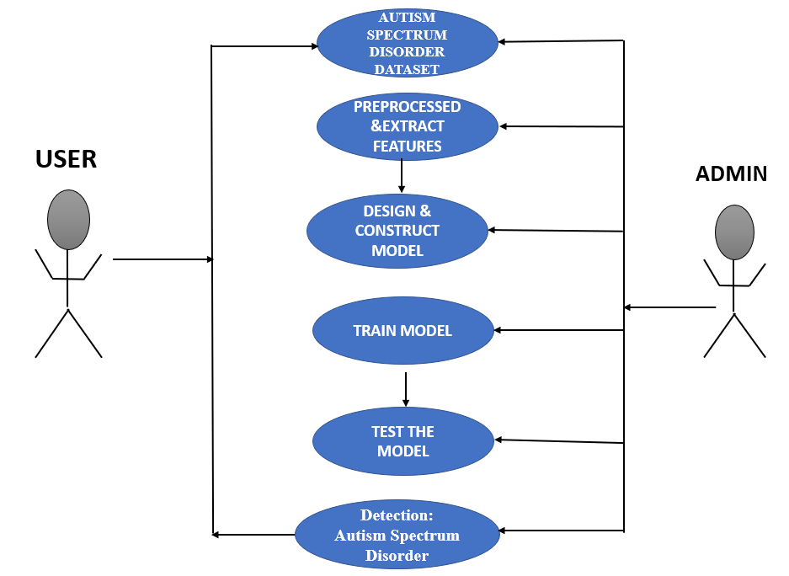
Figure 4.3: Use-Case Diagram
A Use Case Diagram visually represents the interactions between different actors (users or systems) and the system itself. In the context of Autism Spectrum Disorder (ASD) detection, This Use Case Diagram provides a high-level overview of the interactions between the ASD Detection System and the clinician, illustrating key functionalities and their relationships.

CHAPTER 5
METHODOLOGY
The methodology for Autism Spectrum Disorder (ASD) detection involves a systematic approach to building and evaluating a machine learning model that can identify patterns associated with ASD.
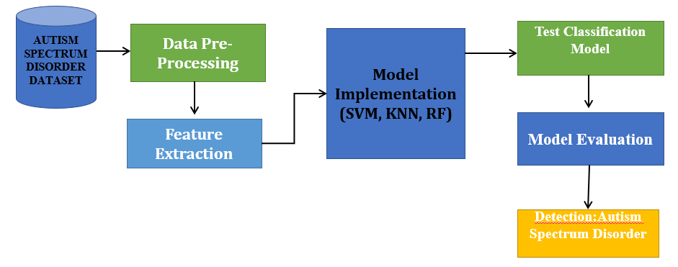
Figure 5.1: Methodology
Data Collection: Gather a diverse dataset with features relevant to ASD detection. Ensure ethical considerations, data privacy, and consent are addressed.Collaborate with healthcare professionals for data collection.
Data Preprocessing: Clean the data, handle missing values, outliers, and noise.Normalize or standardize features to ensure consistent scales. Explore and visualize the data for insights.
Feature Extraction: Extract meaningful features related to ASD. Consider using domain knowledge and feature selection techniques.
Algorithm Selection: Choose appropriate machine learning algorithms (e.g., Random Forest, SVM, Neural Networks) based on the nature of the data and problem.
Model Deployment: Create a user-friendly interface for deploying the model. Implement security measures to protect sensitive data. Ensure compliance with healthcare regulations.
Evaluation Metrics: Define evaluation metrics (accuracy, precision, recall, F1-score) based on the characteristics of the problem. Use cross-validation for robust performance evaluation.
Prediction: It would involve using a trained machine learning model to predict whether an individual may have ASD based on certain input features.

5.1 SVM:
Support Vector Machine or SVM is one of the most popular Supervised Learning algorithms, which is used for Classification as well as Regression problems. However, primarily, it is used for Classification problems in Machine Learning.
The goal of the SVM algorithm is to create the best line or decision boundary that can segregate n-dimensional space into classes so that we can easily put the new data point in the correct category in the future. This best decision boundary is called a hyperplane.
SVM chooses the extreme points/vectors that help in creating the hyperplane. These extreme cases are called as support vectors, and hence algorithm is termed as Support Vector Machine. Consider the below diagram in which there are two different categories that are classified using a decision boundary or hyperplane:
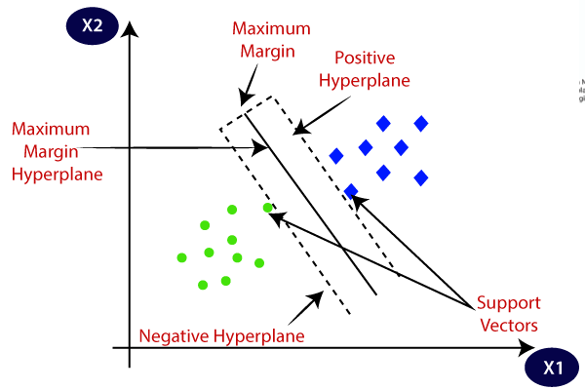
Figure 5.1: SVM Graph
5.2 KNN:
K-Nearest Neighbour is one of the simplest Machine Learning algorithms based on Supervised Learning technique.
K-NN algorithm assumes the similarity between the new case/data and available cases and put the new case into the category that is most similar to the available categories.
K-NN algorithm stores all the available data and classifies a new data point based on the similarity. This means when new data appears then it can be easily classified into a well suite category by using K- NN algorithm.
K-NN algorithm can be used for Regression as well as for Classification but mostly it is used for the Classification problems.
K-NN is a non-parametric algorithm, which means it does not make any assumption on underlying data.
It is also called a lazy learner algorithm because it does not learn from the training set immediately instead it stores the dataset and at the time of classification, it performs an action on the dataset.
KNN algorithm at the training phase just stores the dataset and when it gets new data, then it classifies that data into a category that is much similar to the new data.

CHAPTER 6

SYSTEM REQUIREMENTS SPECIFICATIONS
A Software Requirements Specification (SRS) is a comprehensive description of the intended purpose and environment for software under development. The SRS fully describes what the software will do and how it will be expected to perform. Software requirements specification permits a rigorous assessment of requirements before design can begin and reduces later redesign. It should also provide a realistic basis for estimating product costs, risks, and schedules.
6.1 Software Requirements
6.1.1. Functional Requirements
User Registration and Authentication: User registration and login functionality. User profile creation and management. Users can book appointments and can view the appointment details in their dashboard.
Machine Learning Models: System should implement machine learning models suitable for autism detection. Common models include logistic/linear regression, support vector machines, decision trees, KNN and more. It should support training, validation, and evaluation of these models using appropriate metrics.
Real-time or Batch Processing: Depending on the use case, the system should support both real-time(online) processing of data for autism detection
User Interface and dashboard: There should be a user-friendly interface for clinicians to input patient data, initiate the autism detection process, and view the results. User has their own profile where details of the booked appointment is displayed.
Cross-Validation and Hyperparameter Tuning: The system should perform cross-validation and hyperparameter tuning to optimize the performance of the machine learning models and prevent overfitting.
6.1.2 Non-Functional Requirements
Availability: The online registration system shall permit backing up of the registration database while other registration activities are going on. Online booking appointment is also provided for the patient to book an appointment with the required doctor if ASD predictor comes positive.
Accessibility: The system shall be accessible by people with specific vision needs to the extent that a user shall be able to display the whole user interface in a larger font without truncating displayed text or other values.
Security: The access permissions for system data may only be changed by the systems data administrator passwords shall never be viewable at the point of entry or any other time. Database is only accessible to admin and no private information of the patient is gathered for security purposes.
6.2 Hardware Requirements
• Anaconda Navigator – Streamlit
• OS: Windows/ Linux
• Processor: Intel core i5 processor
• GPU: NVIDIA GeForce/A100
• Memory: 15.6 GB
• Hard Disk: 40 GB

CHAPTER 7
RESULT AND DISCUSSION

Basically, in our project we have 3 Modules.
Module 1: Analysis on Dataset
Module 2: Building Machine Learning Model and Performance Evaluation
Module 3: Created Web Application to demonstrate the result.
Module 1 : Analysis on Dataset
Module 2: Building Machine Learning Model and Performance Evaluation

Module 3: Created Web Application to demonstrate the result.

Figure : Home page

CHAPTER 8
FUTURE SCOPE
The future scope of Autism Spectrum Disorder (ASD) detection holds promising opportunities for advancements in technology, research, and healthcare.
1. Advanced Machine Learning Models: Continued development of more sophisticated machine learning and deep learning models for ASD detection. This includes exploring architectures like transformers, attention mechanisms, and ensemble methods to improve accuracy.
2. Multimodal Data Integration: Integration of data from various sources, such as behavioral observations, speech patterns, neuroimaging, genetic data, and wearable devices. Multimodal data fusion can provide a more comprehensive understanding of ASD and enhance predictive models.
3. Early Detection and Intervention: Emphasis on early detection and intervention strategies. Leveraging machine learning to identify early signs of ASD in infancy or early childhood can significantly improve outcomes by facilitating timely intervention and support.
4. Longitudinal Studies: Conducting longitudinal studies to capture the developmental trajectories of individuals with ASD. Machine learning models can be trained on longitudinal data to identify patterns that may evolve over time, leading to more personalized interventions.
5. Explainable AI in Healthcare: Integration of explainable AI techniques to enhance the interpretability of ASD detection models. Understanding how models arrive at their predictions is crucial, especially in healthcare settings, where interpretability is essential for gaining trust from healthcare professionals.

CONCLUSION
The development of the Autism Spectrum Disorder Detection System marks a significant step forward in the realm of healthcare and technology. Through the careful integration of machine learning algorithms, data analysis, and an extensive dataset, we have strived to create a tool that not only aids in the early diagnosis of Autism but also offers valuable insights for intervention and treatment strategies. As we reflect on the journey of this project, we recognize the immense potential it holds in improving the lives of individuals and families affected by Autism. However, we also acknowledge the ongoing need for collaboration with healthcare professionals, ethical considerations, and continuous refinement to ensure its effectiveness and ethical use. With a commitment to empathy, inclusivity, and rigorous research, we aspire to see this system contribute positively to the broader conversation surrounding Autism Spectrum Disorder diagnosis and care. Our hope is that this project will serve as a catalyst for further innovation and support in the field of Autism research and assistance.

RFERENCES
- Thabtah, Fadi, Firuz Kamalov, and Khairan Rajab. (2018) "A new computational intelligence approach to detect autistic features for autism screening." International journal of medical informatics 117: 112-124.
- Vaishali, R., and R. Sasikala. "A machine learning based approach to classify Autism with optimum behaviour sets. (2018) " International Journal of Engineering & Technology 7(4): 18.
- Fadi Thabtah. (2017). “Autism spectrum disorder screening: machine learning adaptation and DSM-5 fulfillment.” In Proceedings of the 1st International Conference on Medical and Health Informatics, pp. 1-6. ACM.
- Baihua Li, Arjun Sharma, James Meng, Senthil Purushwalkam, and Emma Gowen. (2017) “Applying machine learning to identify autistic adults using imitation: An exploratory study.” PloS one, 12(8): e0182652.
- Thabtah, Fadi. "Machine learning in autistic spectrum disorder behavioral research: A review and ways forward. (2018) " Informatics for Health and Social Care : 1-20.
- Constantino, John N., Patricia D. Lavesser, Y. I. Zhang, Anna M. Abbacchi, Teddi Gray, and Richard D. Todd. (2007) "Rapid quantitative assessment of autistic social impairment by classroom teachers." Journal of the American Academy of Child & Adolescent Psychiatry 46(12): 1668-1676.
- Daniel Bone, Matthew S. Goodwin, Matthew P. Black, Chi-Chun Lee, Kartik Audhkhasi, and Shrikanth Narayanan. (2015) "Applying machine learning to facilitate autism diagnostics: pitfalls and promises." Journal of autism and developmental disorders 45(5): 1121-1136.

